

Acton Gardens LLP
www.youractongardens.co.uk

26th November 2025

Dear Neighbours

South Acton Estate Regeneration: Phase 9.6 (Osborne Road) Tower Crane Dismantle

Dear Neighbours,

Countryside (Vistry), the developer, would like to inform you that from Friday 5th December to Monday 8th December, we will be dismantling one tower crane.
Below is a summary of the approved road closure on Osborne Road, which will be in place during these four days:

- Friday 5th December: A mobile crane will be erected within the approved road closure area, see map below.
- Saturday 6th & Sunday 7th December (08:00 – 18:00): The tower crane will be dismantled.
- Monday 8th December: The mobile crane will be removed, and the road closure lifted.

Please note that these works are weather dependent. Should there be any changes, we will provide an update as soon as possible.

If you have any questions regarding the above, please contact us using the email address provided below. The mailbox will be monitored, and all queries will receive a response.

Thank you for your understanding and cooperation.

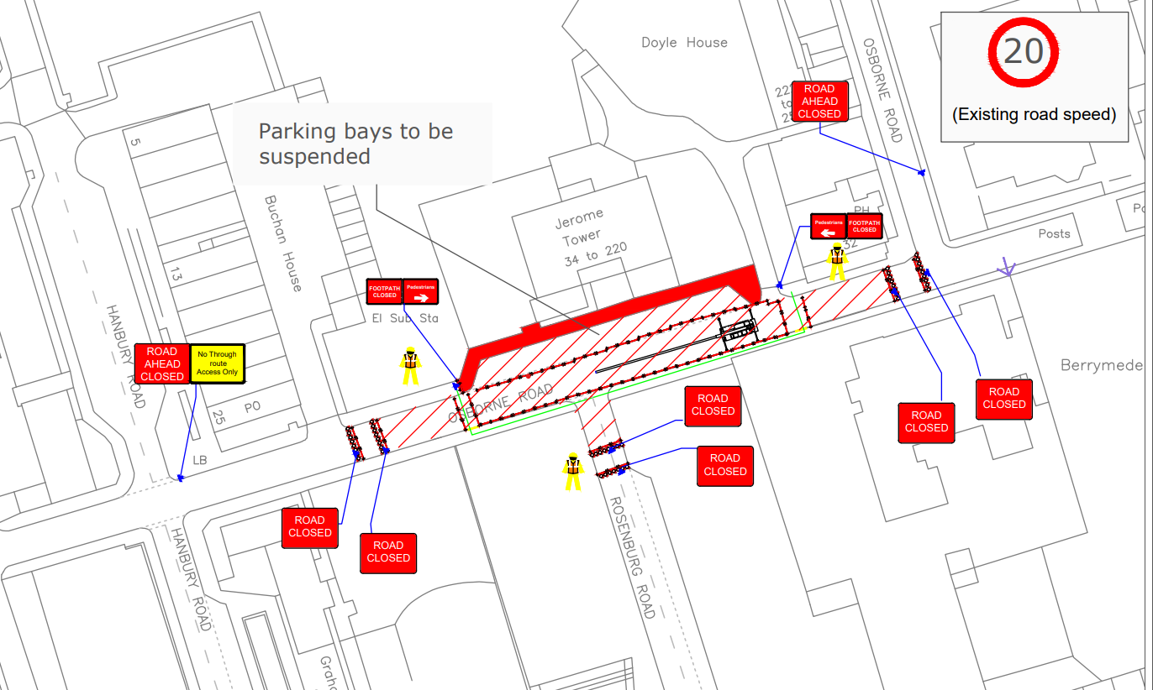

Yours faithfully,
Acton Gardens LLP
WLActonGardens@vistry.co.uk

